1 INTRODUCTION

TechPro IT Solutions, A leading Web Design Company & Digital Marketing Agency with unmatched capabilities & diverse background of building strategic, customizable and insight-driven solutions that maximize Business efficiency & Best ROI.

* 1. Overview

At their most basic, techpro solutions help businesses use their data effectively and efficiently. This includes creating, management, accessing, collecting, analyzing, optimizing, reporting, and presenting relevant information related to customers, employees, services, and processes.

* 1. PURPOSE

Nowadays it very important to mobilize your business by providing your customers with trending easy to use Mobile Apps made by the experts in Mobile Technology. We at TechPro make trending Mobile Apps that give best user experience resulting in overall sales enhancement. We provide any kind of app whether it is custom or native, iOS or Android

1. PROBLEM DEFINITION & DESIGN THINKING

In Today's world everyone is constantly searching for good or services online weather it's a needle or a tower, but the question is, is your business or services visible to them...? if not, then Online marketing is the only technique which can be used to promote your services or to optimize your website for search engines and target potential customers using digital marketing.

* 1. Empathy Map

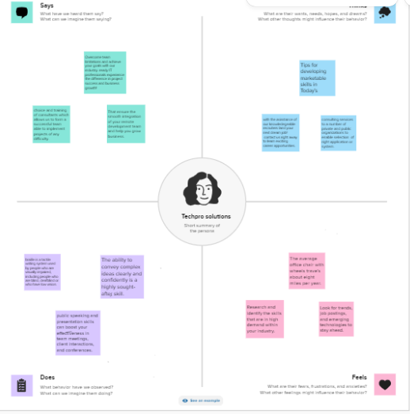

* 1. IDEATION & BRAINSTROMING MAP

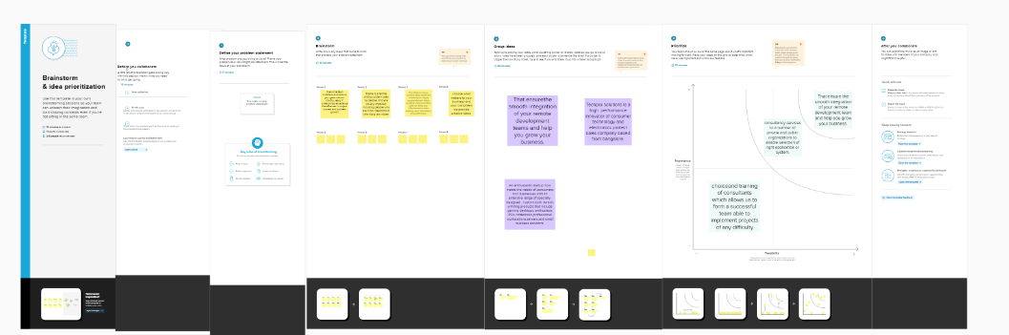

1. RESULT

It utilize the latest technology to provide sophisticated and secure IT solutions using an effective delivery model to ensure flexibility and agility. Our specialty of operations includes Application Lifecycle Management, Infrastructure Lifecycle Management and Product Lifecycle Management. Our “High performance business” strategy builds on our expertise in consulting, technology and outsourcing to help clients perform at the highest levels so that they can create sustainable value for their customers and shareholders.

Profit & loss a/c

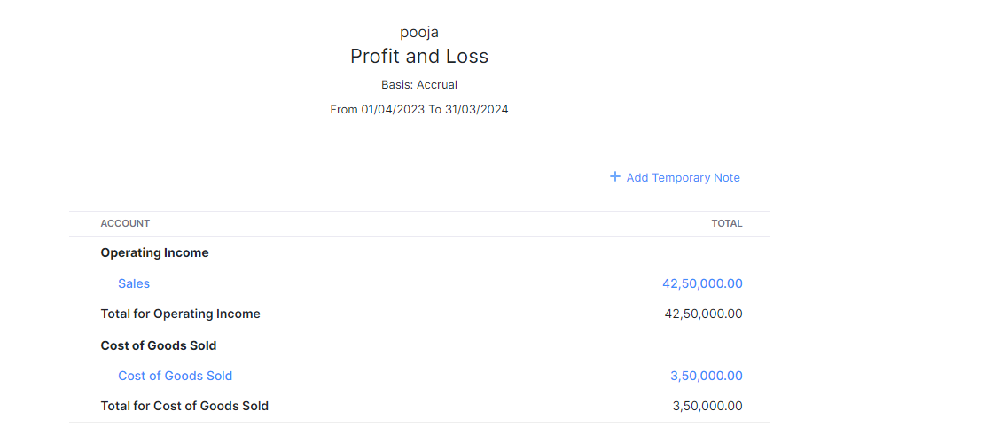

Balance sheet

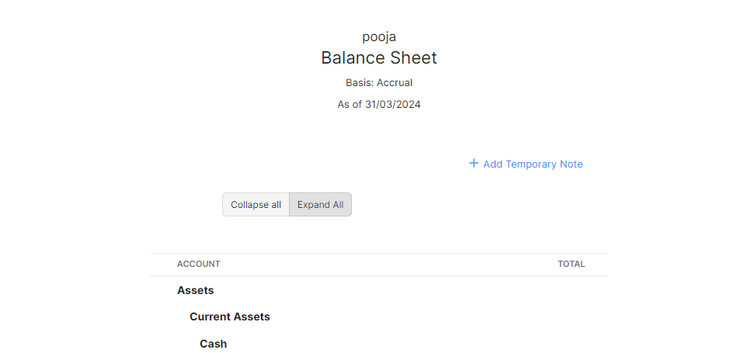

1. ADVANTAGES & DISADVANTAGES

It can help engineers understand if their proposed solutions for ne products or features will satisfy customers, leading to the development of new product platforms.

It can also enable TechPro Solutions to navigate the complex world of strategic issues and become or stay a solution provider by managing various strategic tasks such as product development, human resources, process management, marketing, procurement, and logistics.

Additionally, completing the Customer Validation stage can contribute to the evaluation of users' experience and enhance product usability by assessing emotional and reflective components of users' product experience.

1. APPLICATIONS

**Information technology industry**

1. CONCLUSION

Techpro Solutions provides a full-range of services that are essential to the success of your business. We provide technology solutions and custom software development for businesses of all sizes. With proven results and quality professional services, Techpro can build, design and implement the most advanced software for your organization.  
Our core competencies are in the area of software development with more than 10 years of experience. We offer top quality tech solutions to small and big companies in India.

1. FUTURE SCOPE

To channelize the Knowledge, Expertise and Experience that has gained over the years from recommending IT products and Effective solutions for our Customers. Deep industry knowledge and exceptional technical expertise combined with best business ethics makes TechPro the global leader in IT Services and Management Consulting.